**Horra Bug Report**

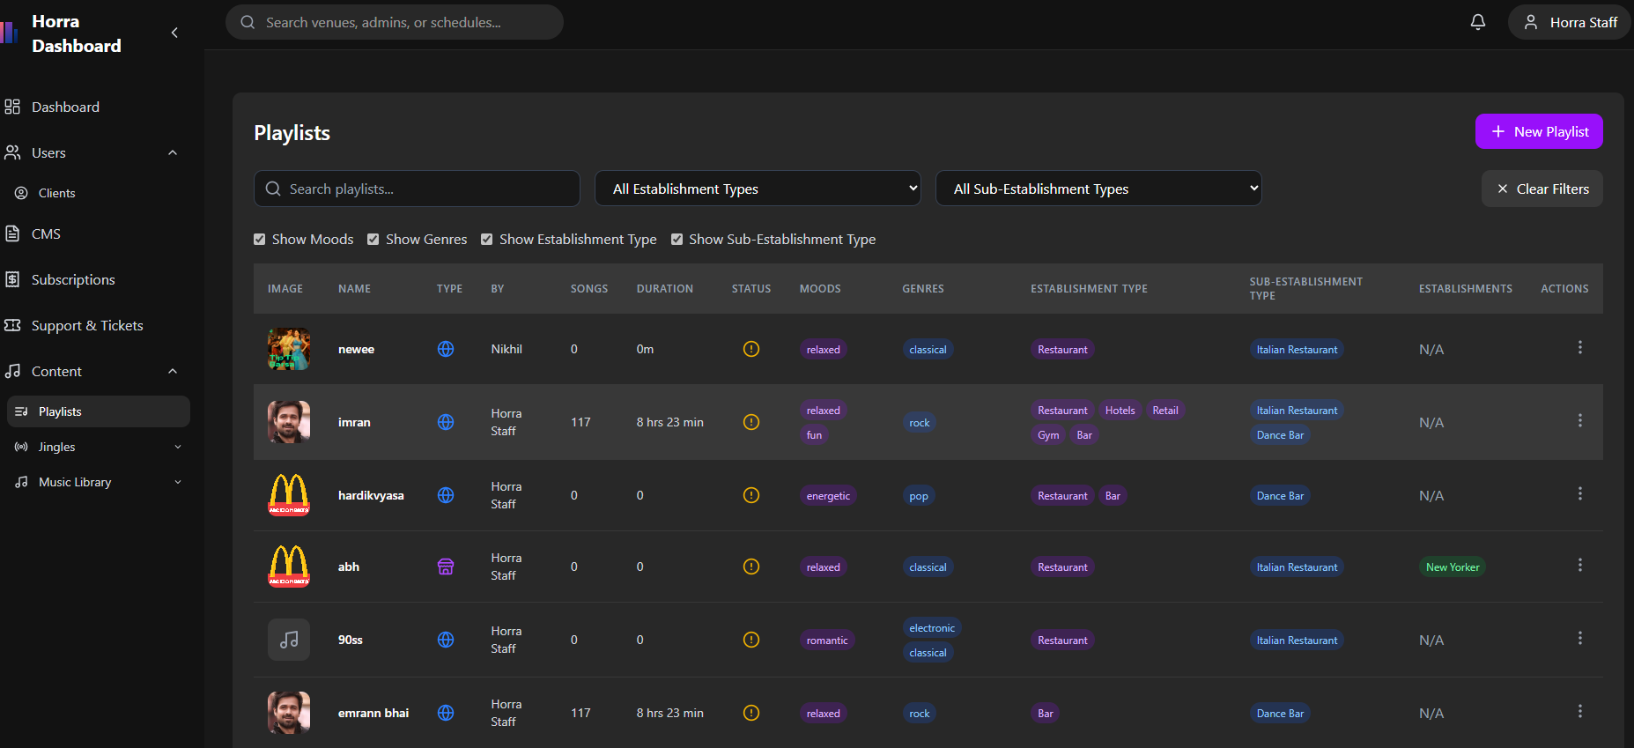

**Playlist successfully created but song not import properly (Super Admin)**

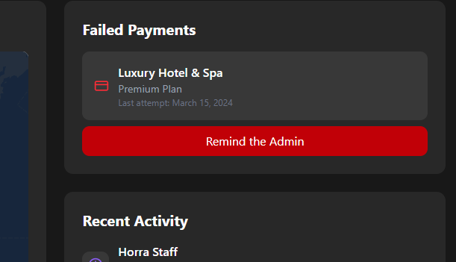

**11. The "Remind the Admin" button is not responsive. (Super Admin)**

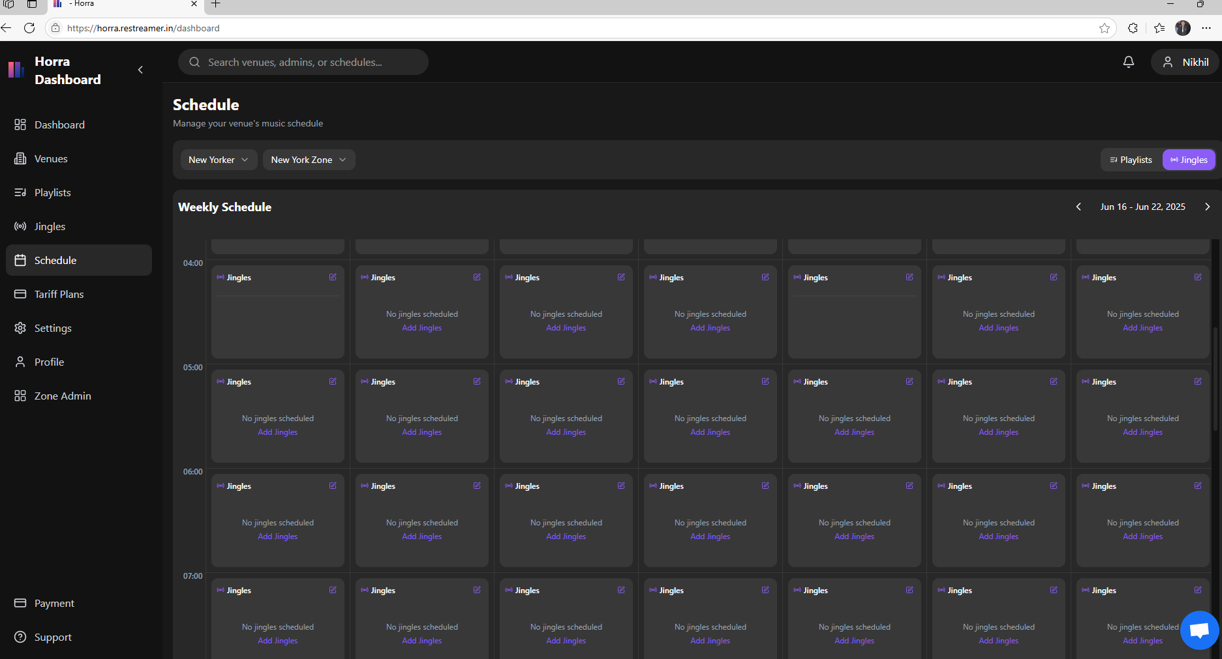

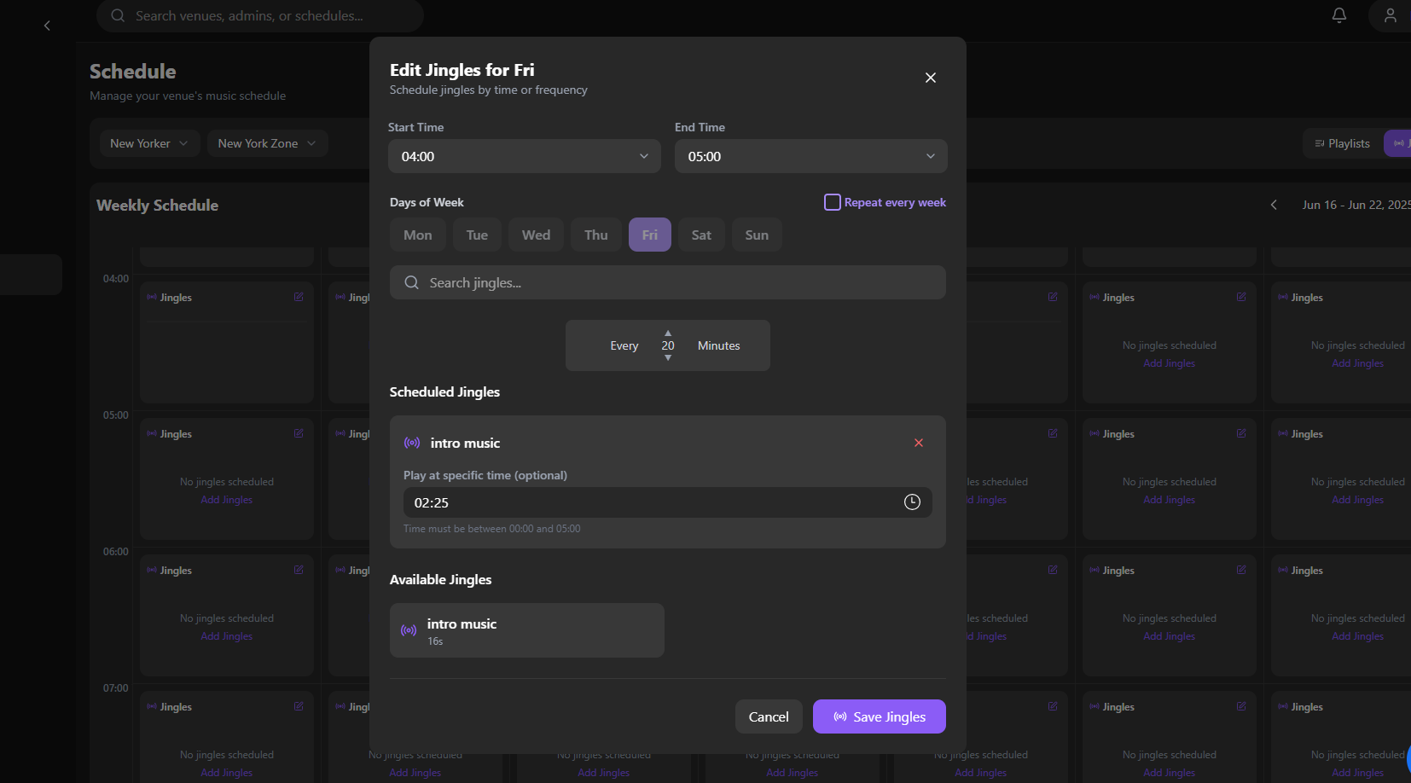

**13. when in edit jingles form when I select start time 04:00 to end time 05:00. then in scheduled music why it gives permission to select out of this 04:00 to 05:00. and when click on save jingles then it saved then why it save.**

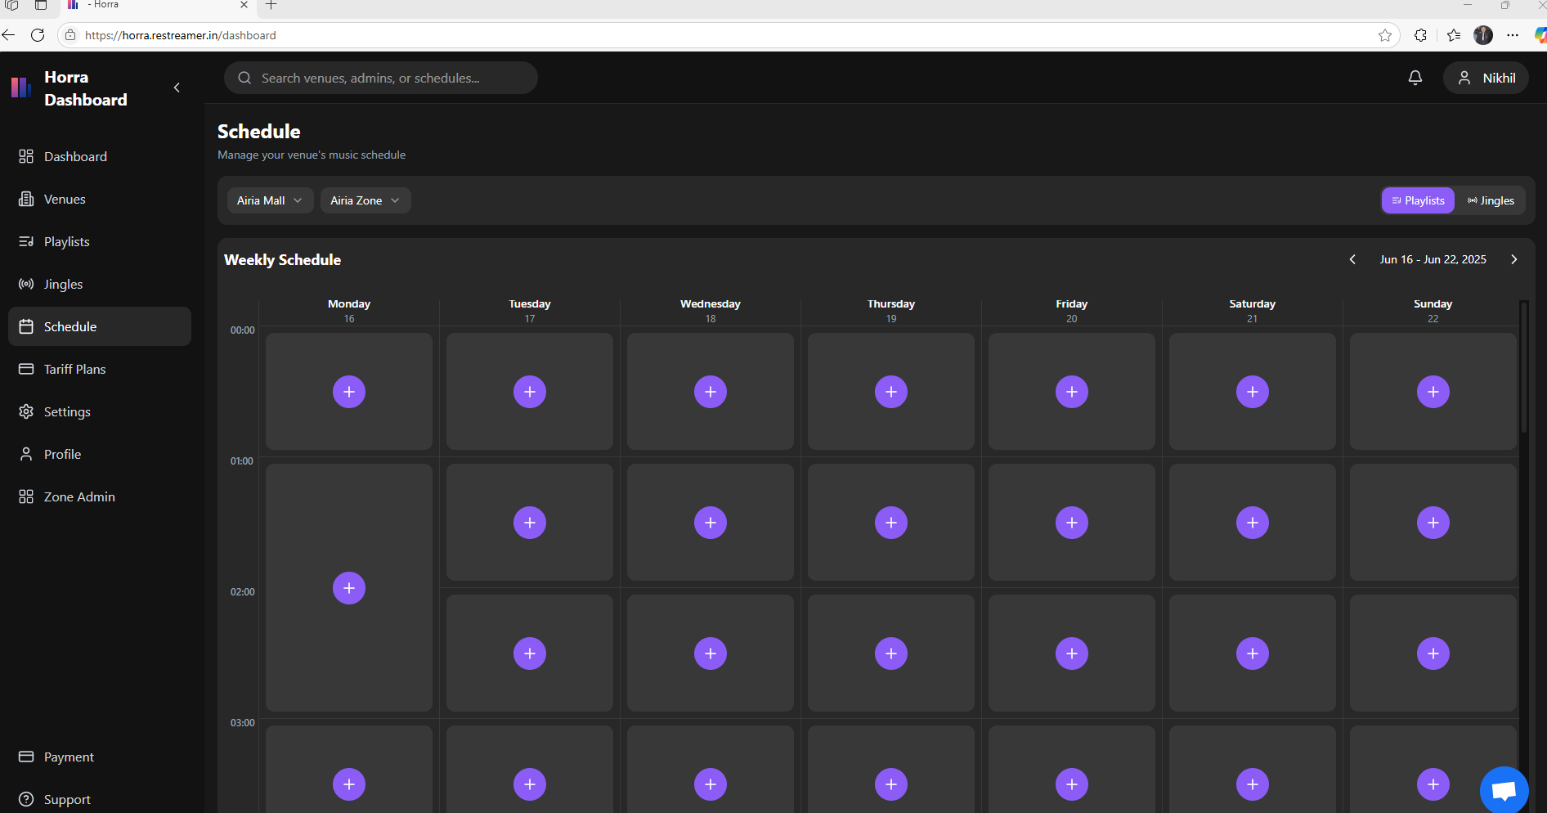

**15. when I delete the playlist but the gap is not deleted. gap remains same.**

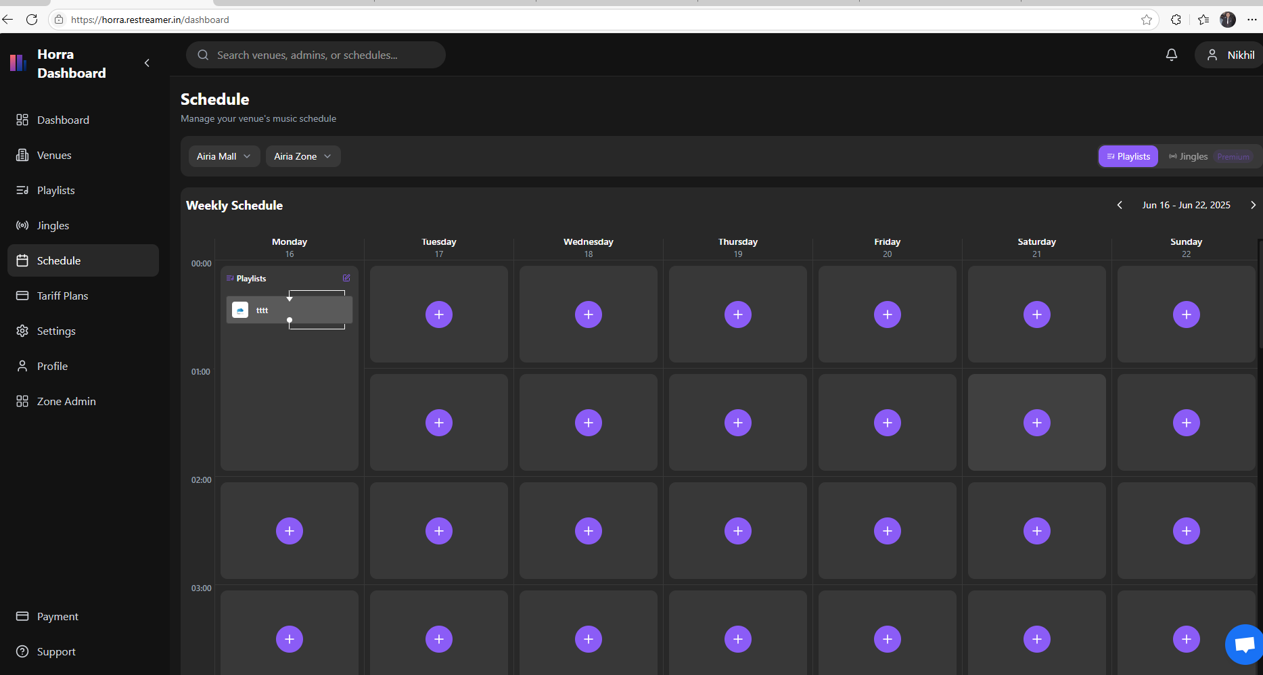

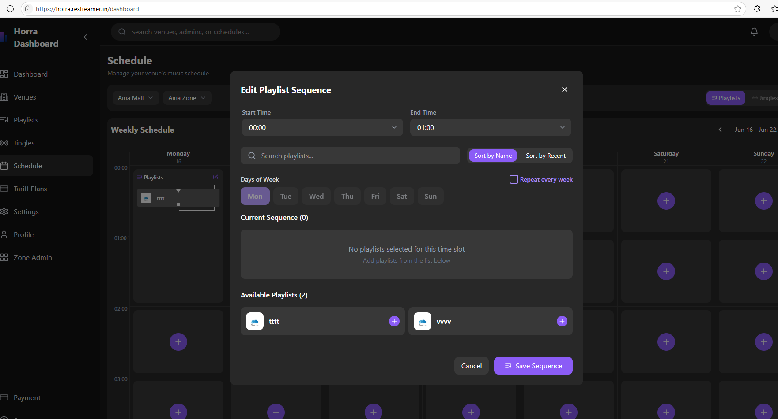

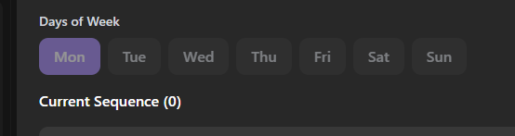

**16. When we click on + icon below Any days (Ex: Friday) then in days of week option it auto selects Mon. After save sequence it save in Friday filed correctly.**

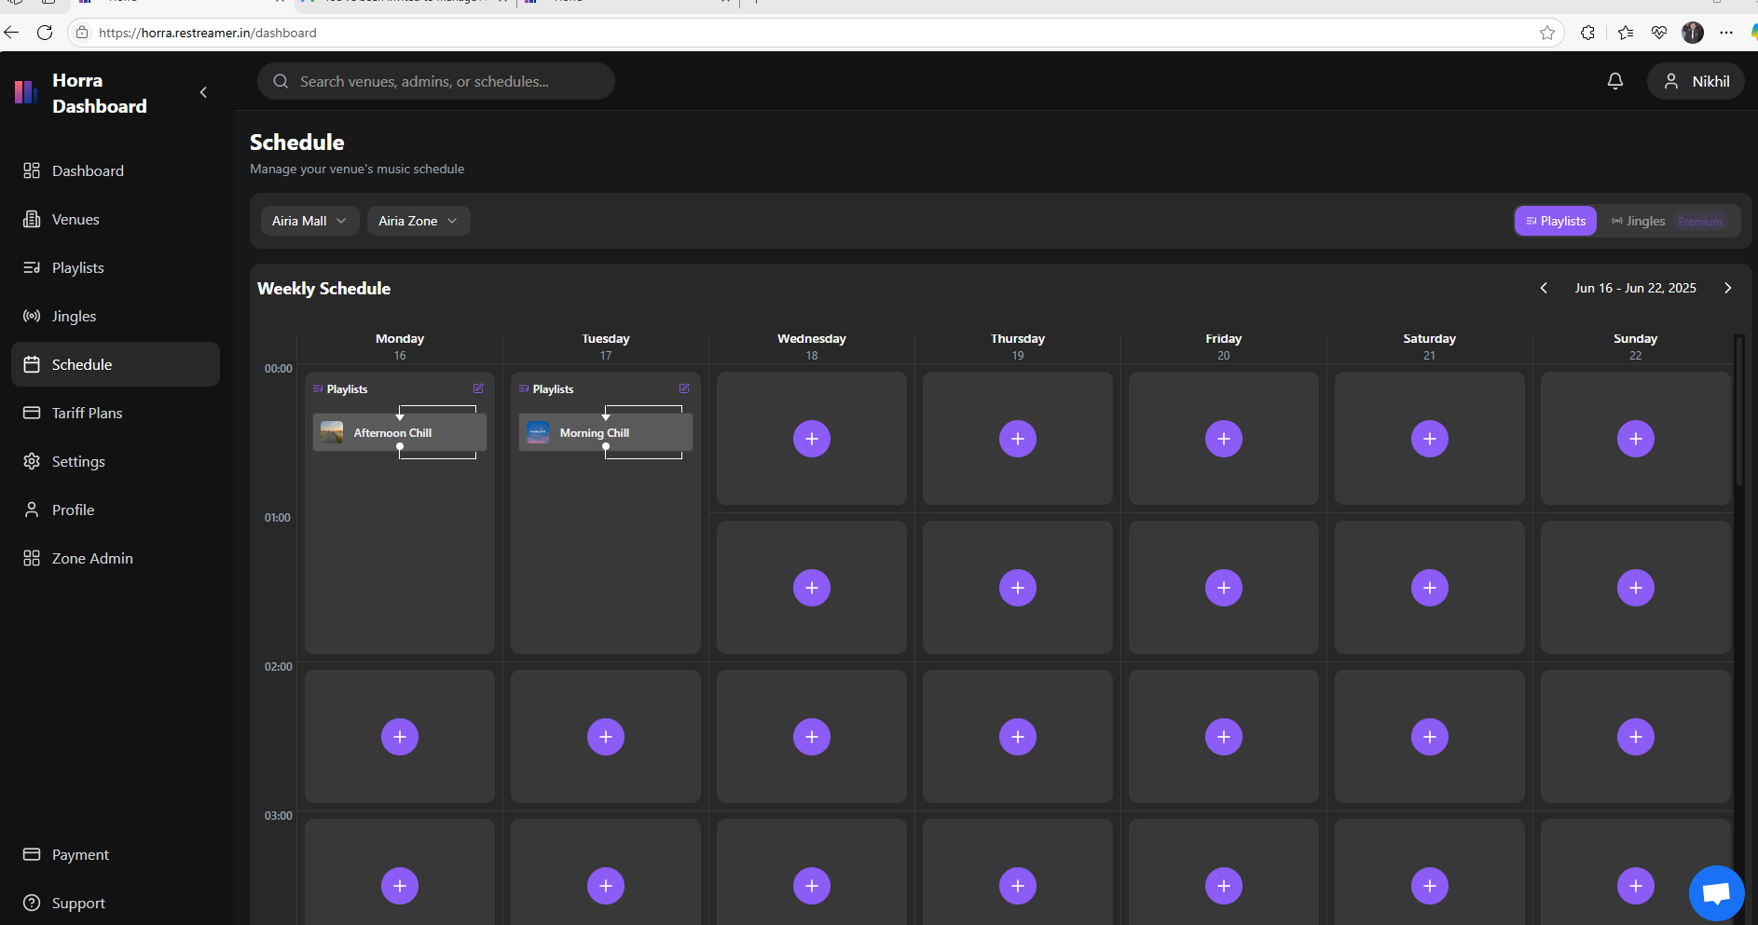

**Click on edit function of Tuesday.**

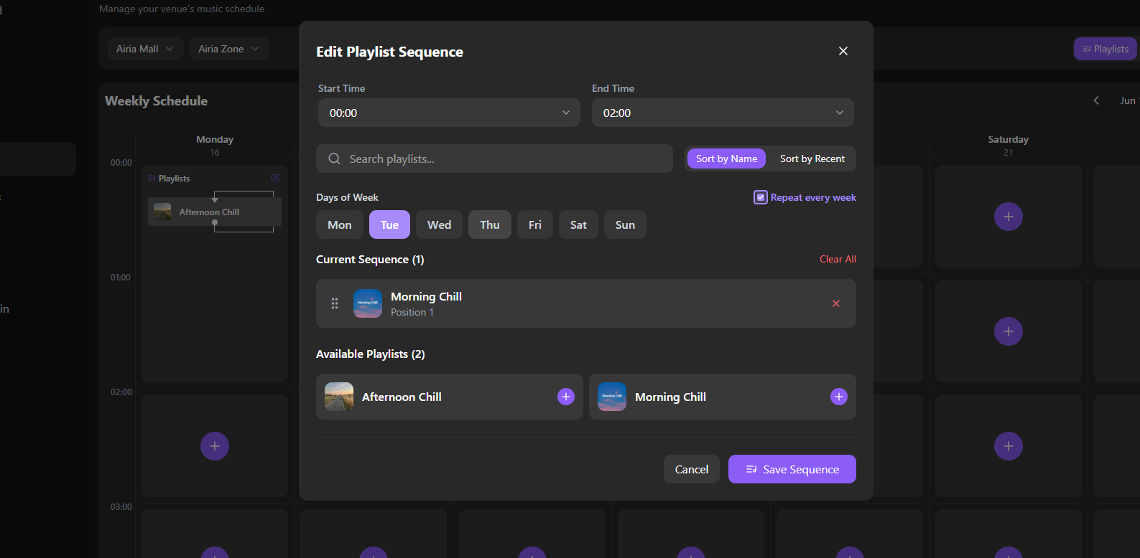

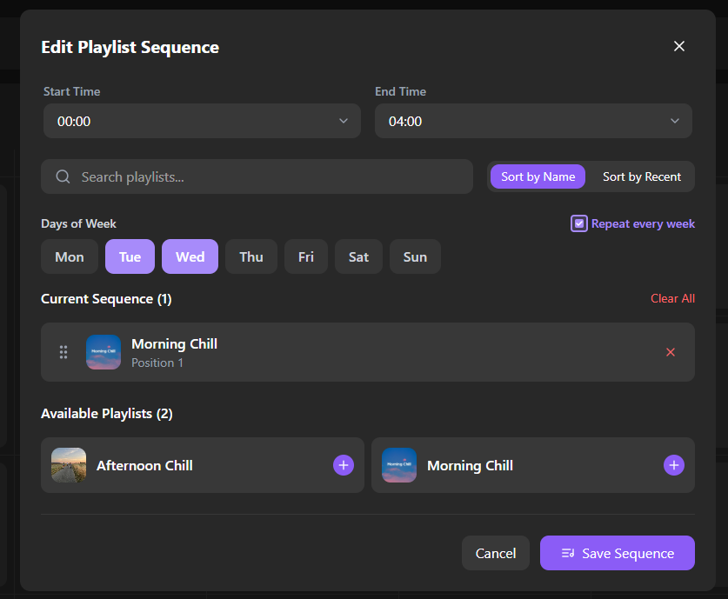

**17. In this form I select multiple days of week (Ex: wed) and then click on save button then saved days of week will not be reflected**

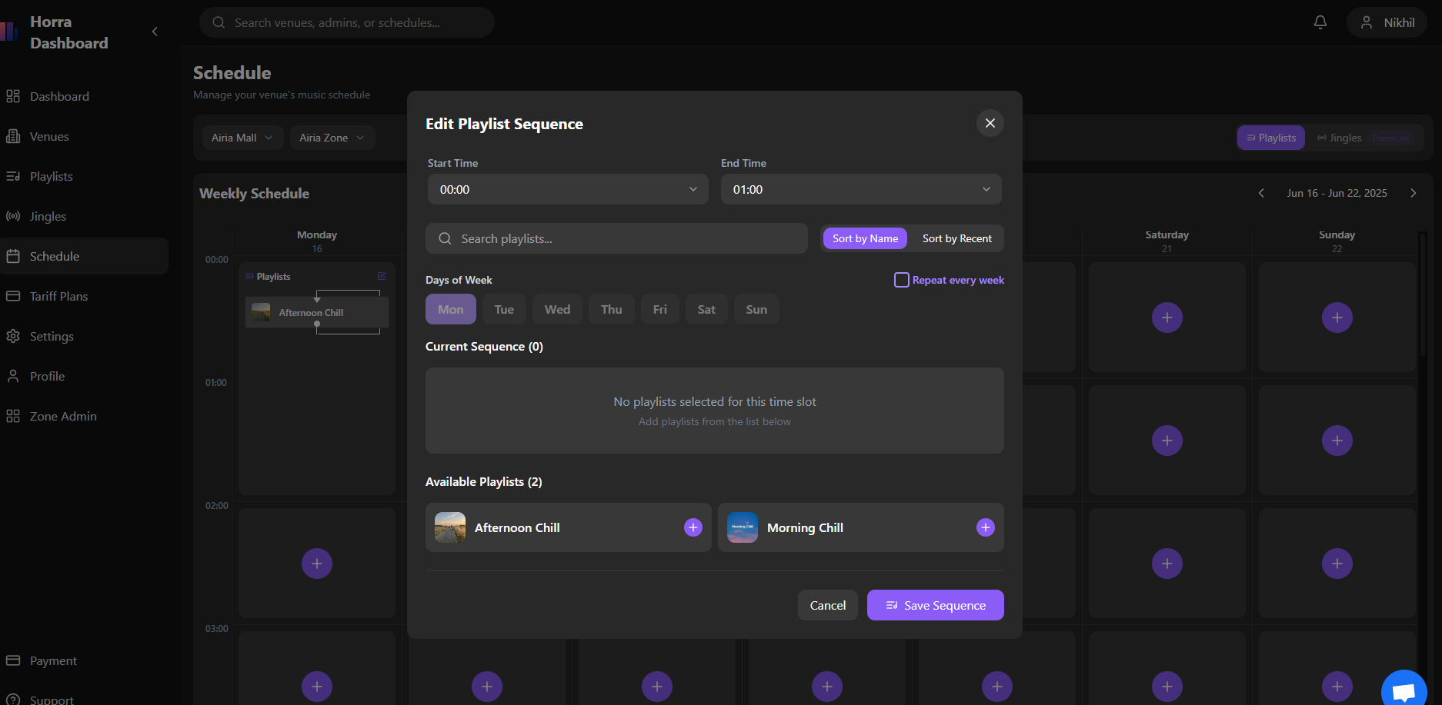

**18. When we click on any days + icon then new form will open then it auto selects Mon directly.**

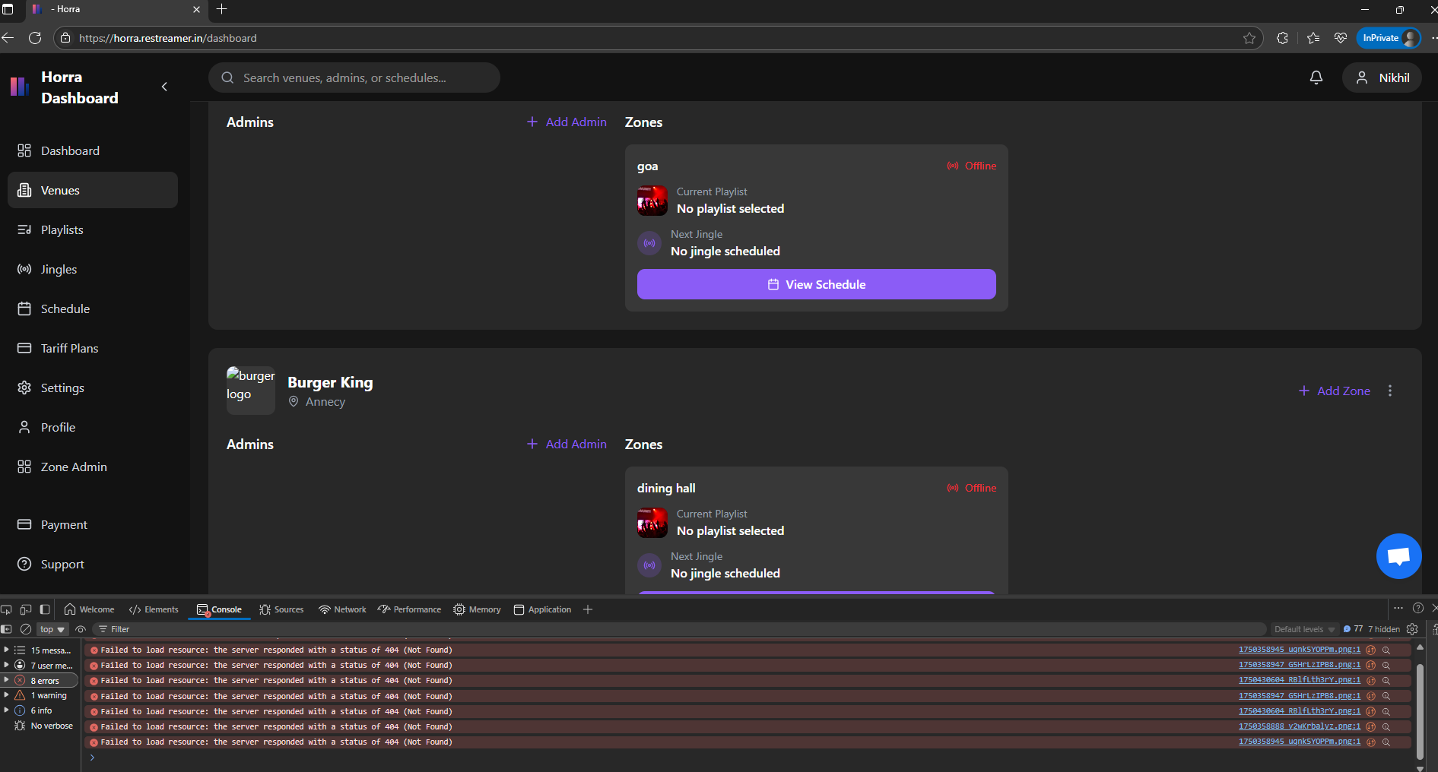

**19. failed to load logo**

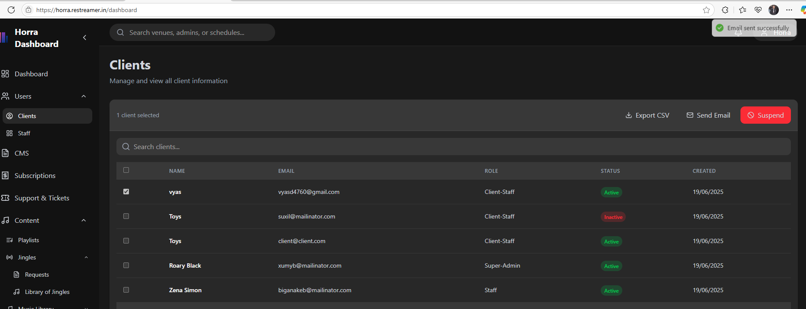

**20. Email sent successfully popup appear but mail not delivered.**

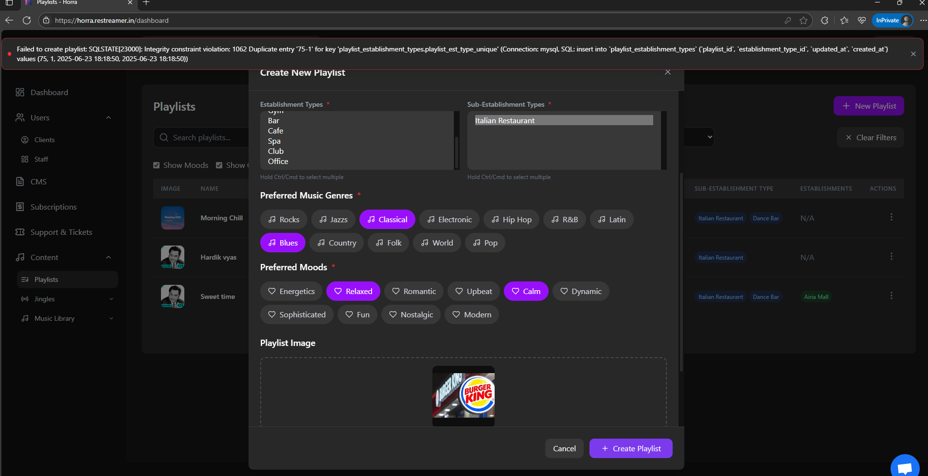

**21.Failed to create playlist (super admin).**

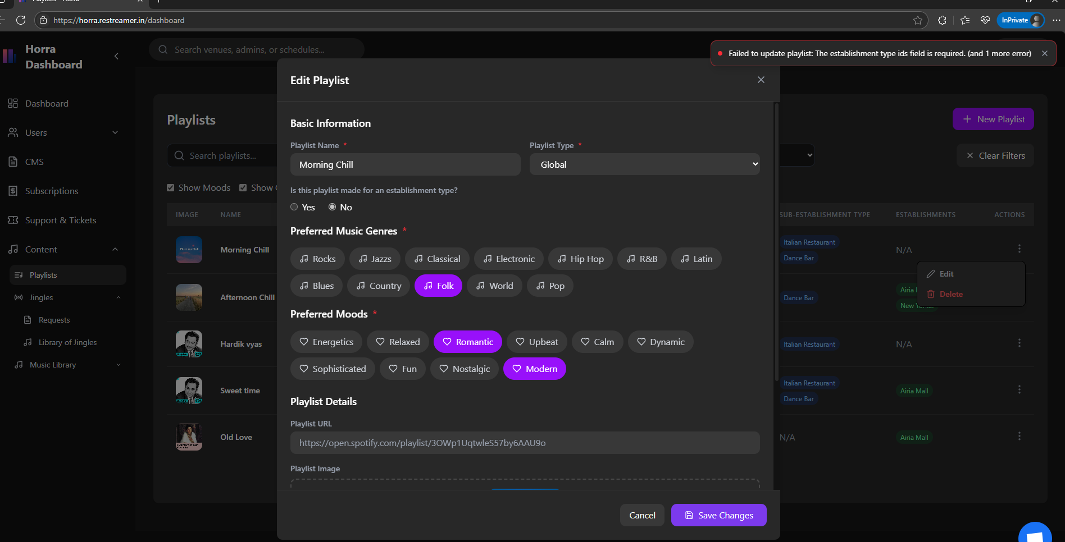

**22.In playlist option when we click on edit option then we try to save changes it not saved and show error failed to update playlist.**

**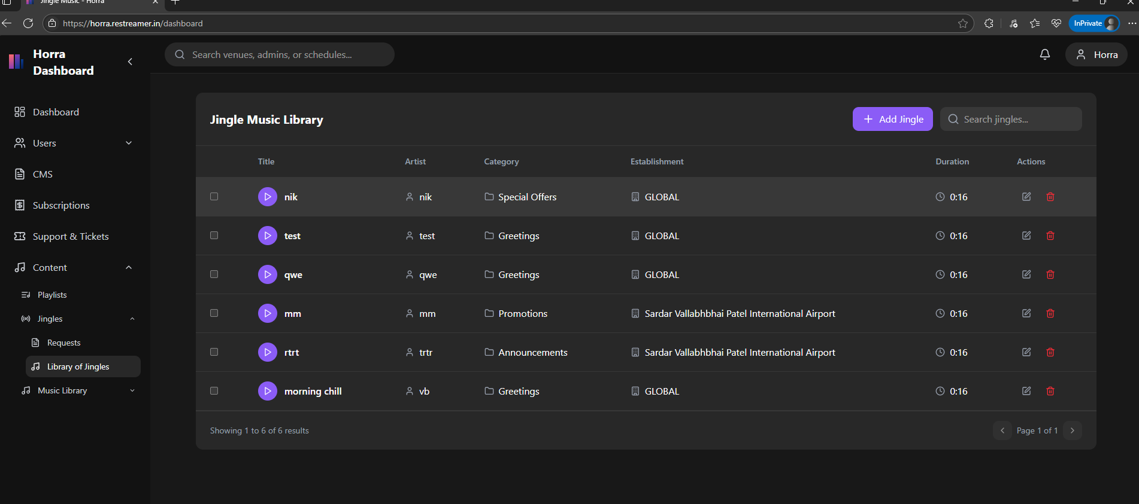  
  
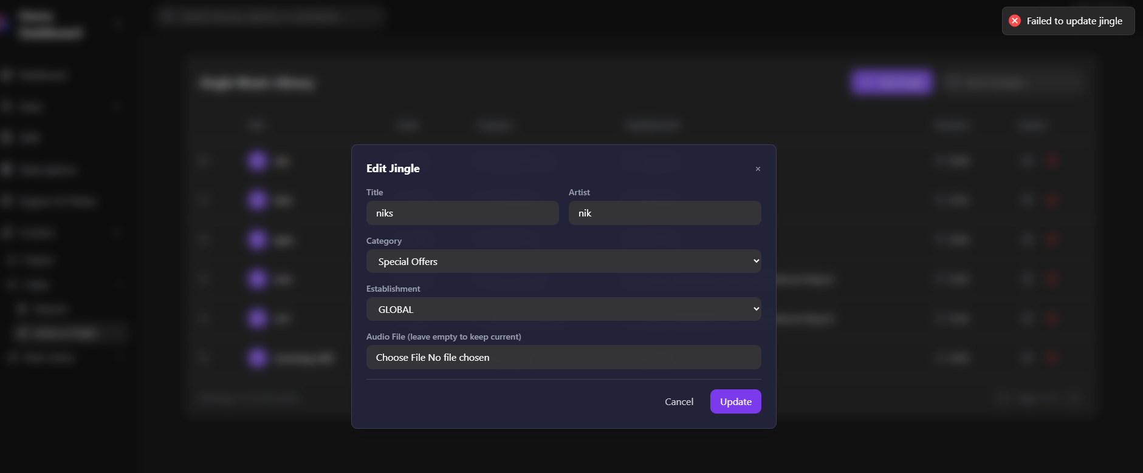**

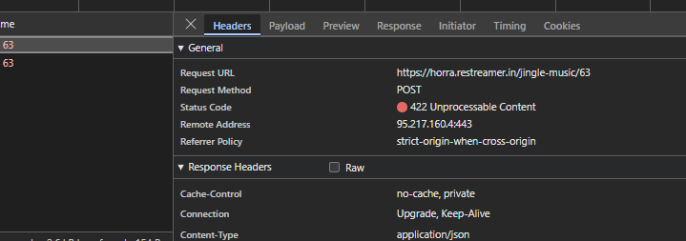

**23. In library of Jingles option when we click on edit option and try to edit then it shows error of failed to upload jingles. It shows error only when we select GLOBAL in Establishment field**

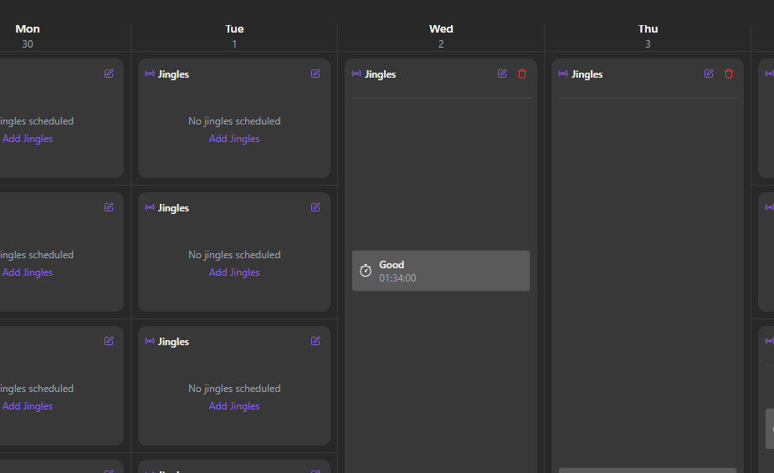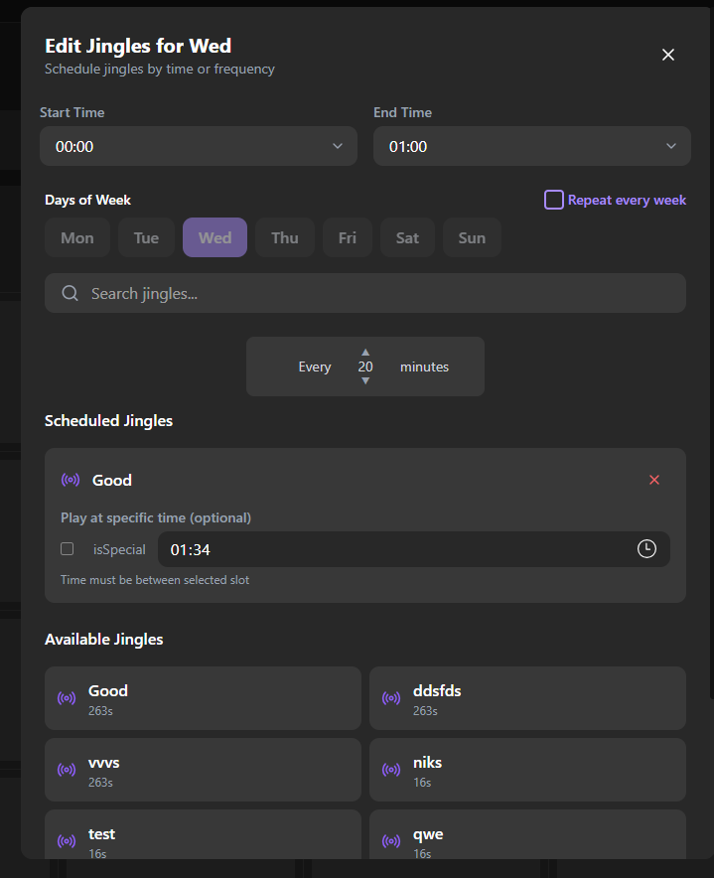 **24. We select time of 00:00 to 04:00 then save it again we click on edit then why end time start from 01:00. Why**

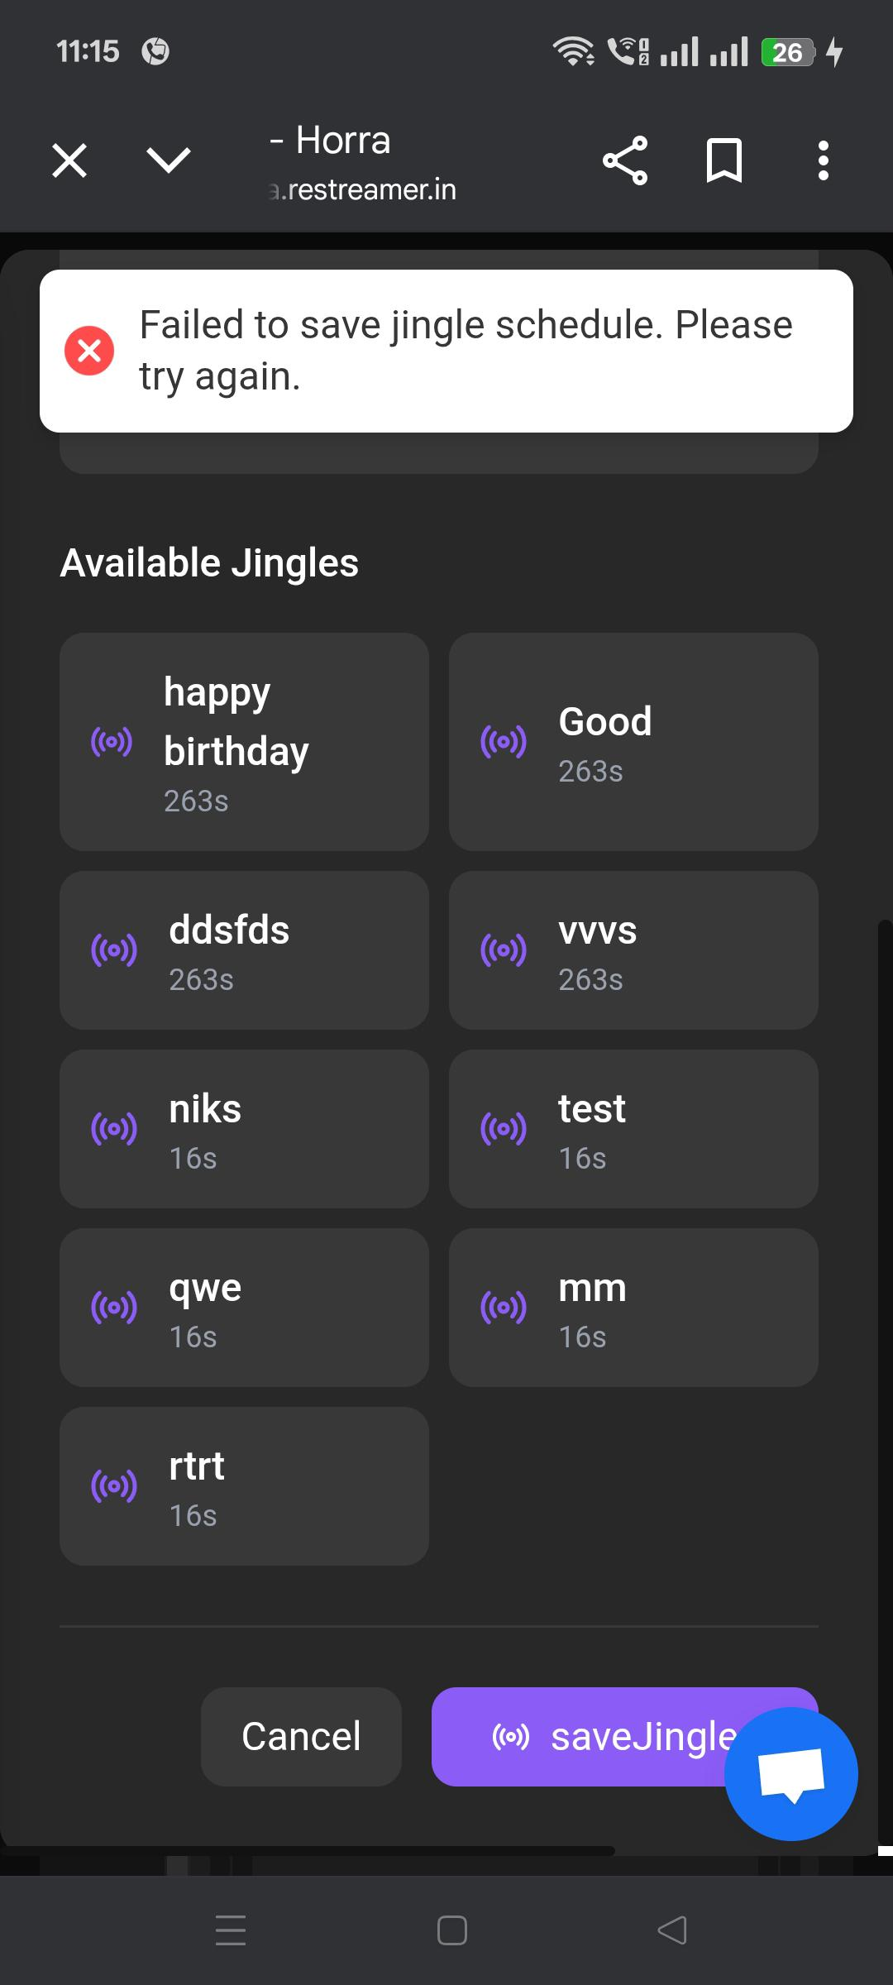

**25. When we don’t select jingles in this form but it not show sweet alert it show error message.**

**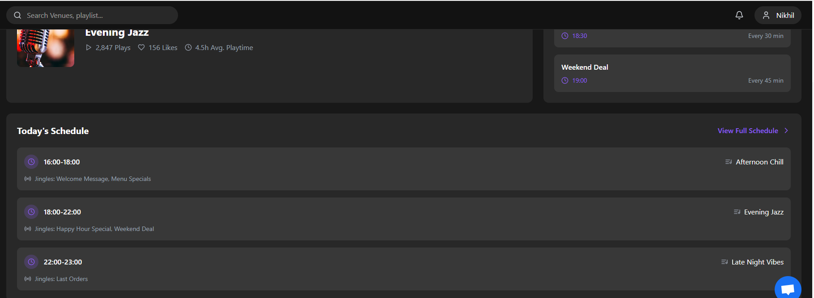  
  
26. View Full Schedule button is not working.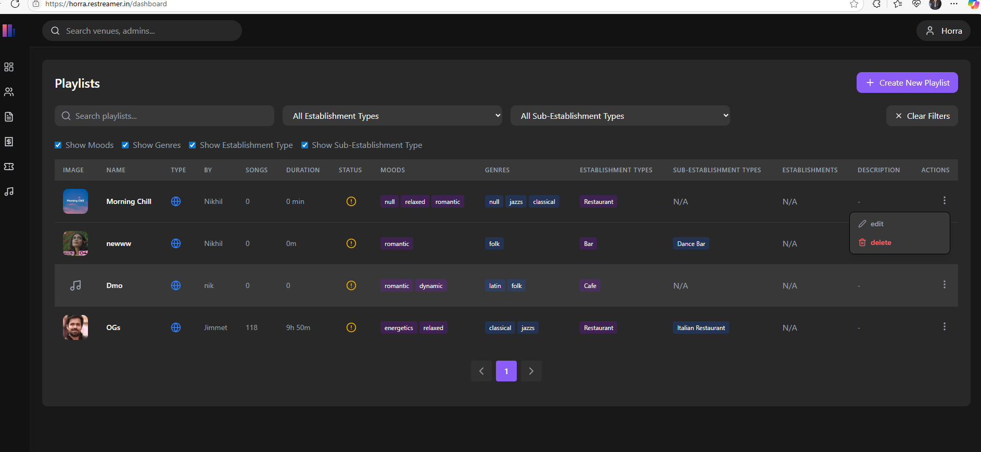 27. When the edit and delete option is appear then if we click on where on screen then it not disappears automatically. if we want to disappear then we need to click on three dot line**